SIX WEEKS INDUSTRIAL TRAINING PROJECT REPORT

ON

VIDEO ON DEMAND

Bachelor Of Technology

In

COMPUTER SCIENCE AND ENGINEERING

BATCH

(2017 – 2021)



Submitted to HOD(CSE) Submitted by

Er. VINOD SHARMA DEEPINDER SINGH

(1701255)

GULMEHAK KAUR

(1701260)

SHRISH SAINI

(1701370)

DEPARTMENT OF COMPUTER SCIENCE & ENGINEERING

Amritsar College of Engineering and Technology Amritsar

**ACKNOWLEDGEMENT**

I am highly grateful to Er. VINOD SHARMA for providing this opportunity to carry out the six Weeks industrial training. It was purely on the basis of his/her experience and knowledge that I am able to clear all the theoretical and technical hurdles during the development phases of this project work.

I want toexpress gratitude to other faculty members of Department of Computer science and Technology for their intellectual support throughout the training Course.

DEEPINDER SINGH

(1701255)

GULMEHAK KAUR

(1701260)

SHRISH SAINI

(1701370)

**Certificate**

**TABLE OF CONTENTS**

|  |  |  |
| --- | --- | --- |
| **Sr. No.** | **Topic** | **Page No.** |
|  | Introduction to Organization | 7 |
| 2. | Front End | 10 |
| 3. | Back End | 13 |
| 4. | Tools Used | 16 |
| 5. | Introduction to Project | 18 |
| 6. | Hardware & Software Requirements | 19 |
| 7. | Table Schema | 20 |
| 8. | Project Screen Shots | 21 |
| 9. | Bibliography | 34 |

**INTRODUCTION TO ORGANIZATION**

The Institute where we are pursuing our six months Industrial Training is VMM (Veenus Mind Media), at Amritsar*.*

**DETAILS OF VMM**

VMM Education’s journey started in January 2005 with a vision of bringing computer education of global standard in the holy city of Amritsar. To turn this dream into reality we needed to create a talent pool of bright young minds who would power the engines of growth of the global economy, Today seven years later VMM Education or VMM, as it is popularly known as, is the largest and the most trusted computer centre of the region, with annual turn out of more than 1000 students each year. The reason for the success of VMM is simply the “Hard work” that our team has put in these seven years.

In this past 7 years, VMM Education has provided world class training in global technologies such as Java , Net , Oracle and Linux , while keeping our syllabus up to date with the current industry standard. We have managed to successfully train more than 7000 engineers who are currently working in Global Multinationals like TCS, Tech Mahindra, Infosys, and CSC etc.

VMM is today the favourite choice of students of various engineering college for pursuing their six months or six weeks industrial training. A unique “industry-endorsed curriculum,” crafted by professionals of VMM enhances the job-readiness and employability of learners and equips them for the IT Industry.

To provide IT education which can match with the global IT standards, VMM also undertake industrial projects under the banner of Venus Software Solutions (VSS as the Venus Software solution is popularly known as undertake projects from UK & USA example **im4schools.co.uk**) this also allows our students to work on the live projects and make projects for the various industries. Some of our products include Point of sale software for Super Markets with barcode reader support, Finger print attendance Management System that can work for school, colleges and other institutes, Remote Lan Controller which can be used to view remote desktops on LAN or WAN.

VMM has the world class computer labs that are equipped with the latest Hardware and software so that the practical of the students must always remain for that and we continuously upgrade our hardware and software every 6 months.

Attendance of students is one of the major features of VMM, students are required to record their day to day attendance using Biometric Finger print recognition device this allows us to provide accurate attendance of students to their parents and college during their training time.

**Some Key learning solutions for Individuals include the following:**

* **Foundation course**

This course includes two languages C and C++ that allows us to build a strong foundation of programming for the beginner and First year & Second year engineering graduates

* **Six Weeks Industrial training**

This training program which is of 42 working days allows the 3rd year engineering graduates to get hands on experience on either of the following technologies VB.Net, C#.Net, SQL & Core java. This training is pretty intensive as the students are required to spend 4-8 hours at the institute learning any one the above languages along with developing a project by working in team, this allows students to learn how to work as team member and also gets hands on training on the latest technology.

* **Six Months Industrial Training**

Doing your six months industrial training at VMM is a very special experience for any engineering graduate as it allows the students to nurture his / her knowledge by working on Technologies like ASP.Net, Silverlight, J2EE, Struts, Ajax, Android etc. The candidate is required to spend almost whole day at institute doing their Lab practical or attending their tutorial lecture and developing a project which they can submit in their college as a part of dissertation. This program is for the final year B.Tech students who can learn latest technologies like VB.Net, C#.Net, ASP.Net or Java and make their project.

* **Individual Skill enhancement programs**

Apart from above training program VMM provides a bouquet of courses in windows application development using VB.Net/C#.Net/Java, Web Development using ASP.Net or J2EE, Mobile Software development in Android.

Venus Mind Media or VMM is a Software Solutions Provider. The company specializes in providing industry-focused solutions and customized development. The development work ranges from management oriented solutions utilizing the latest of databases, design and programming tools to web development designing and Network resources.

**The Group**

Venus Mind Media is a software arm of Hotel Venus International (Amritsar), it is one of the fastest growing software solution provider extending its arms in diversified activities such as School & College Network AMC’s, Wi-Fi Internet Management solutions in school/colleges/Shopping Malls & Hotels, customized software development, Web-Site Development & Web Marketing (SEO) The total Turnover of entire group is more than 5 million (INR)

Sister concerns:

a) Hotel Venus International

b) S.K Tour & Travels

c) Harmind Shawls

d) Jaws Arts

VMM commenced its operations in the year 2004 as 100% software consultants. VMM was started from one home computer and today VMM has got infrastructure of more than one million (INR).VMM operates it two wings one is of the software consultancy services and other is **VMM Education** i.e. the Education wing which deals with providing the world class computer education to its students

**FRONT END**

Java is a general purpose and the most popular object-oriented programming language. Java was developed by James Gosling and his colleagues at Sun Microsystems in the early 1990’s.

Due to its simplicity and easy to learn and advanced features, we opted this language for our six months industrial training. This language supports many interesting features that make it an ideal language for software development. In addition to the object oriented features, it also provides features such as platform independence, security, multithreading, portability; etc which makes it well suited for the web and networked services, applications, platform-independent desktops, robotics and any other embedded devices*.*

**Features of Java:**

* **Simple**: Java is a compact and simple language. Programs are easy to write and debug as it omits many clumsy, poorly understood and confusing features of other programming languages such as C++.
* **Object-oriented:** Java is purely object-oriented language because programming in java is centre on creating objects; manipulating objects and making objects work together.
* **Distributed:** Java is a distributed language which means that the programs can be designed to run on computer networks. Java provides an extensive library of classes for communicating using TCP/IP protocols such as HTTP and FTP. This makes creating network connections much easier.
* **Robust:** Java is designed for writing programs that are highly robust. By robust, we mean reliable.
* **Secure:** As java is intended to be used in networked/distributed environments so it implements several security mechanisms to protect you against malicious code that might try to invade your file system.
* **Architectural Neutral:** This means that the programs written on one platform can run on any other platform without having to rewrite or recompile them. It follows ‘Write-once-run-anywhere’ approach.
* **Portable:** In Java, the size of the primitive data types is machine independent. These consistencies make java program portable among different platforms such as Windows, UNIX and Mac.
* **Interpreted:** Java is such a language that is both compiled and interpreted. The two steps of compilation and interpretation allow extensive code checking and improved security.
* **High performance:** Java programs are complied with portable intermediate form known as byte codes, rather than to native machine level instructions and JVM executes java byte codes on any machine on which it is installed. This architecture means that java programs are faster.
* **Multithreaded:** Java is also a multithreaded programming language. It allows you to write a program that can do many tasks simultaneously.
* **Dynamic:** Java is designed to be dynamic. Classes are stored in separate files and are loaded into the Java Interpreter only when they are needed.

**JAVA DEVELOPMENT KIT (JDK)**

The Java Development Kit (JDK) is a software package that sun has made available to public. It includes all the basic components that makeup the java environment. These include the Java compiler, Java Interpreter, an applet viewer that lets you see applets without opening a Java-compatible web browser.

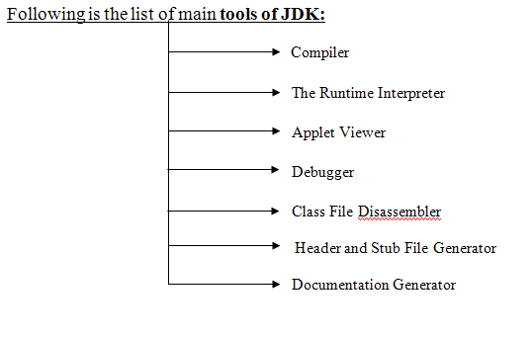

**APPLICATIONS OF JAVA**

Java has evolved from a simple language providing interactive dynamic content for webpage to a predominant enterprise-enables programming language suitable for developing significant and critical applications.

Today, Java is used for many applications like:

* Web based applications
* Financial applications
* Gaming applications
* Embedded applications
* Distributed enterprise applications
* Mobile applications
* Image applications
* E-business applications
* Desktop applications and many more.

**SOCKET PROGRAMMING IN JAVA**

Clients and Servers establish connections and communicate via sockets. Connections are the communication links that are created over the Internet using TCP. Some client/server applications are also building around the connectionless UDP. These applications also use sockets to communicate.

**A Socket is an abstraction through which an application, may send and receive data.**

There are two types of sockets used in socket programming in java:

* **Stream Socket:** A Stream Socket is a connection oriented socket, thus a connection has to be established before it can send or receive data. Data that one end of the connection writes to the socket is available for reading at the other end of the socket connection. The Stream Sockets use TCP protocol for data transmission.
* **Datagram Socket:** Datagram Socket is a connectionless socket, thus no actual connection is established between two communicating hosts. The datagram socket use UDP protocol for data transmission. Since UDP does not guarantee that all packets are received in the correct order or not also with UDP the packets can even be lost or dispatched.
* **Raw Sockets:** Some protocols such as ICMP or OSPF that directly us the services of IP, use neither stream nor datagram sockets. Raw Sockets are designed for these types of applications.

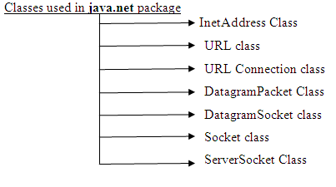**The java.net package contains fundamental classes for communication and working with network resources.**

**BACK END**

**MySQL**

MySQL is an open source Relational Database Management System. MySQL is very fast reliable and flexible Database Management System. It provides a very high performance and it is multithreaded and multi user Relational Database management system.

MySQL is one of the most popular relational database Management System on the web. The MySQL Database has become the world's most popular open source Database , because it is free and available on almost all the platforms. The MySQL can run on Unix, window, and Mac OS.

MySQL source code is available that's why now you can recompile the source code.

**Features:**

The following list describes some of the important **Features of my SQL** Database Software.

* Internals and Portability
* Written in C and C++.
* Tested with a broad range of different compilers.
* Works on many different platforms.
* The **MySQL** code is tested with Purify (a commercial memory leakage detector) as well as with Valgrind , a GPL tool
* The server is available as a separate program for use in a client/server networked environment. It is also available as a library that can be embedded (linked) into standalone applications. Such applications can be used in isolation or in environments where no network is available.
* Column Types
* Many column types: signed/unsigned integers 1, 2, 3, 4, and 8 bytes long, FLOAT, DOUBLE, CHAR, VARCHAR, TEXT, BLOB, DATE, TIME, DATETIME, TIMESTAMP, YEAR, SET, ENUM, and Open GIS spatial types.
* Fixed-length and variable-length records.
* Statements and Functions
* Full operator and function support in the SELECT and WHERE clauses of queries.
* Full support for SQL GROUP BY and ORDER BY clauses. Support for group functions (COUNT (), COUNT (DISTINCT ...), AVG (), STD (), SUM (), MAX (), MIN (), and GROUP_CONCAT ()).
* Support for LEFT OUTER JOIN and RIGHT OUTER JOIN with both standard SQL and ODBC syntax.
* Support for aliases on tables and columns as required by standard SQL.
* DELETE, INSERT, REPLACE, and UPDATE return the number of rows that were changed (affected). It is possible to return the number of rows matched instead by setting a flag when connecting to the server.
* Security
* A privilege and password system that is very flexible and secure, and that allows host-based verification. Passwords are secure because all password traffic is encrypted when you connect to a server.
* Scalability and Limits
* Handles large databases. We use **MySQL** Server with databases that contain 50 million records. We also know of users who use **MySQL** Server with 60,000 tables and about 5,000,000,000 rows.
* Up to 64 indexes per table are allowed (32 before **MySQL** 4.1.2). Each index may consist of 1 to 16 columns or parts of columns. The maximum index width is 1000 bytes (500 before **MySQL** 4.1.2). An index may use a prefix of a column for CHAR, VARCHAR, BLOB, or TEXT column types.
* Connectivity
* Clients can connect to the **MySQL** server using TCP/IP sockets on any platform. On Windows systems in the NT family (NT, 2000, XP, or 2003), clients can connect using named pipes. On Unix systems, clients can connect using Unix domain socket files.
* In **MySQL** versions 4.1 and higher, Windows servers also support shared-memory connections if started with the --shared-memory option. Clients can connect through shared memory by using the --protocol=memory option.
* The Connector/ODBC (My ODBC) interface provides **MySQL** support for client programs that use ODBC (Open Database Connectivity) connections. For example, you can use MS Access to connect to your **MySQL** server. Clients can be run on Windows or Unix. My ODBC source is available. All ODBC 2.5 functions are supported, as are many others.
* The Connector/J interface provides **MySQL** support for Java client programs that use JDBC connections. Clients can be run on Windows or Unix. Connector/J source is available.
* Localization
* The server can provide error messages to clients in many languages.
* Full support for several different character sets, including latin1 (ISO-8859-1), German, big5, ujis, and more. For example, the Scandinavian characters 'â', 'ä' and 'ö' are allowed in table and column names. Unicode support is available as of **MySQL** 4.1.
* All data is saved in the chosen character set. All comparisons for normal string columns are case-insensitive.

**TOOLS USED**

**NetBeans - integrated development environment**

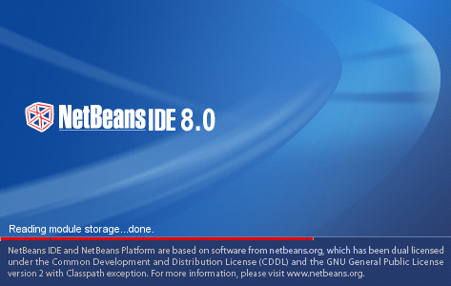

**NetBeans** IDE is a free, open source, popular integrated development environment used by many developers. Out of the box, it provides built-in support for developing in Java, C, C++, XML, and HTML. And this author especially likes the support for editing JSPs, including syntax highlighting, HTML tag completion, JSP tag completion, and Java code completion.

The basic steps for making a new project in java are as follows.

1. Create a new project

2. Mount a directory - specify a location to save project files

3. Add a new class to the project

4. Compile and run a Java program

**Minimum Hardware Configurations**

* Microsoft Windows XP Professional SP3/Vista SP1/Windows 7 Professional:
* Processor: 800MHz Intel Pentium III or equivalent
* Memory: 512 MB
* Disk space: 750 MB of free disk space
* Solaris OS version 10 (SPARC):
* Processor: Ultra SPARC II 450 MHz
* Memory: 512 MB
* Disk space: 650 MB of free disk space
* Solaris OS version 10 (x86/x64 Platform Edition):
* Processor: AMD Opteron 1200 Series 1.8 GHz
* Memory: 512 MB
* Disk space: 650 MB of free disk space
* Macintosh OS X 10.5 Intel:
* Processor: Dual-Core Intel (32 or 64-bit)
* Memory: 512 MB
* Disk space: 650 MB of free disk space

**INTRODUCTION TO PROJECT**

**Video on demand** is a system that allows users to select and watch **video** content of their choice on their TVs or computers. **Video on demand** is one of the dynamic features offered by Internet Protocol TV. **VOD** is basically the opposite of live **streaming** giving users the opportunity to watch **video** at any suitable time and from any Internet-connected devices.

**Benefits**

Here are five benefits of video on demand over linear TV you should know of if you are thinking of being a traditional TV alternative connoisseur

1. **Convenience**
2. **Connectivity**
3. **Cost**
4. **Variety**
5. **Devices**

**Objective Of Our Project**

Video on demand is a programming system which allows users to select and watch/listen to video or audio content such as movies and TV shows whenever they choose, rather than at a scheduled broadcast time

**HARDWARE REQUIREMENTS:**

Hardware requirements include that hardware which is required for its working. It includes:

* Pentium 4 Computer
* 512 MB RAM
* High Speed Internet Connection (DSL/Cable)

**SOFTWARE REQUIREMENTS:**

The technical specifications of requirements for the software are as follows:

* Any Operating System (Windows, Linux, MAC)
* Java run time environment
* NetBeans (Java IDE)
* Java SDK (Software Development Kit)
* Any web browser (Chrome, Firefox, etc)

**TABLE SCHEMA**

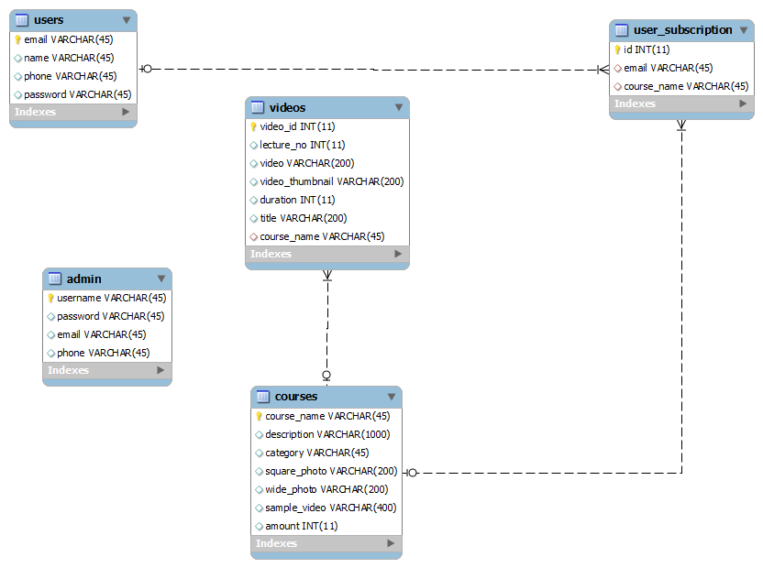

**PROJECT SCREENSHOTS**

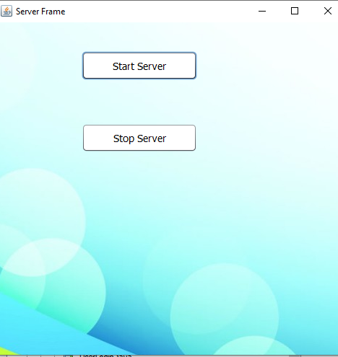

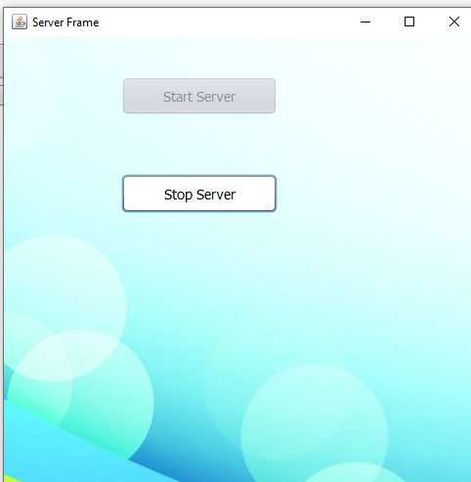

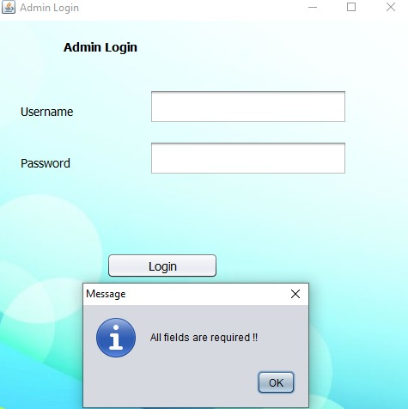

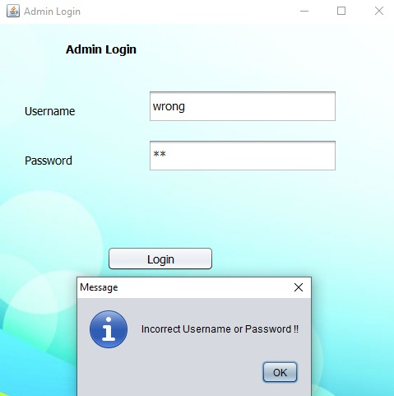

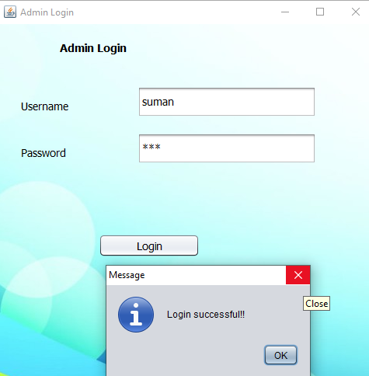

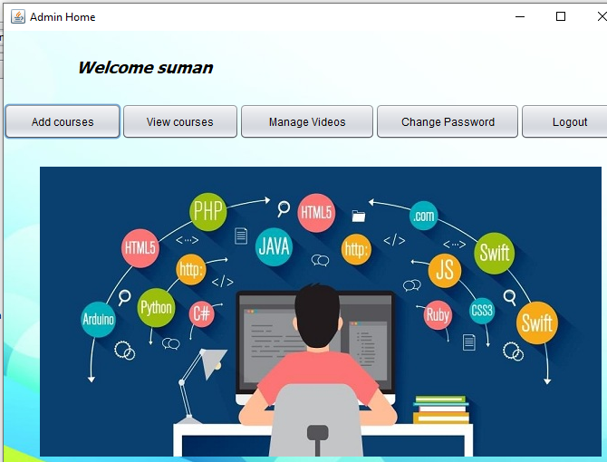

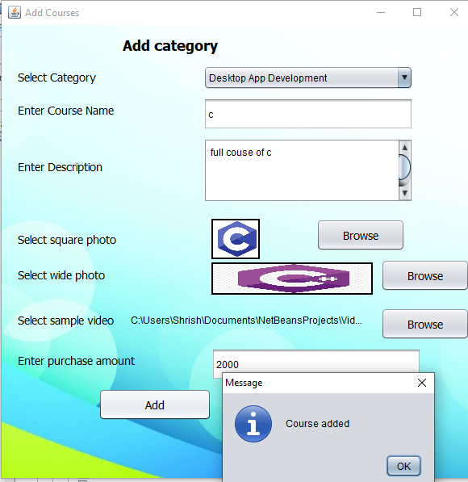

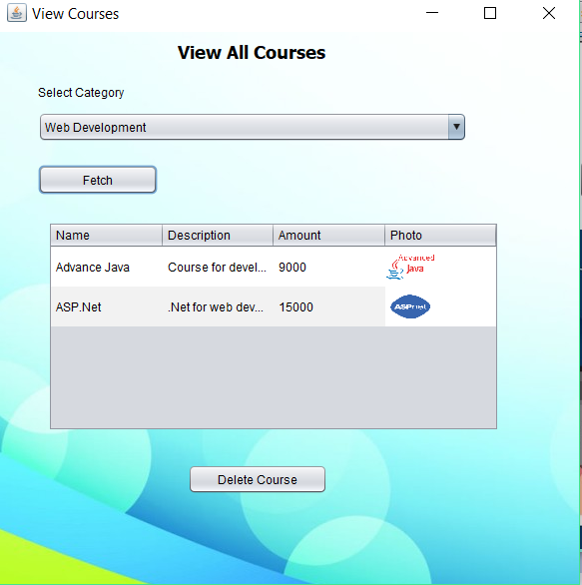

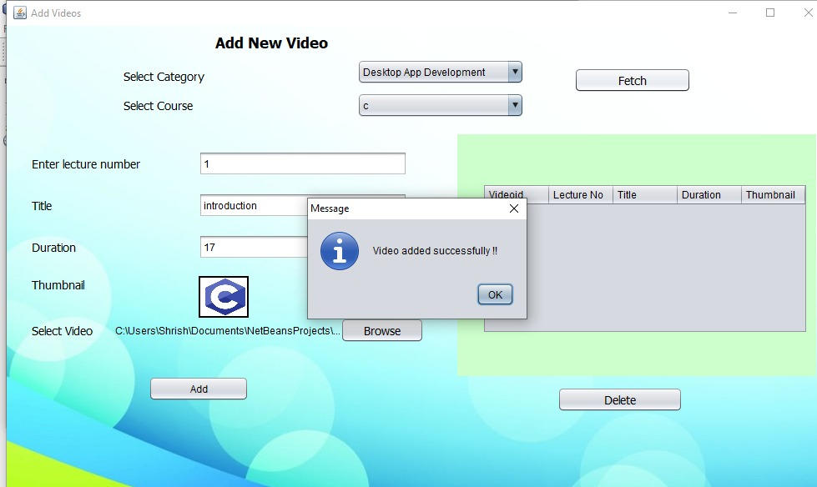

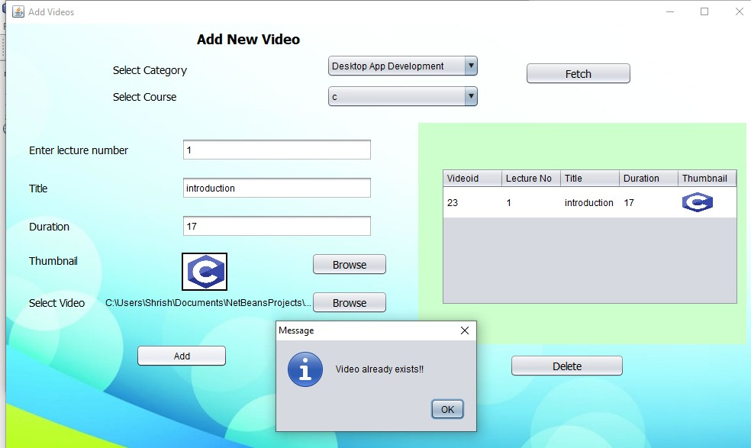

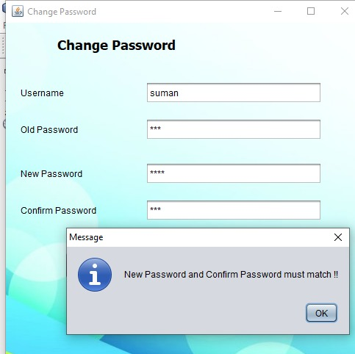

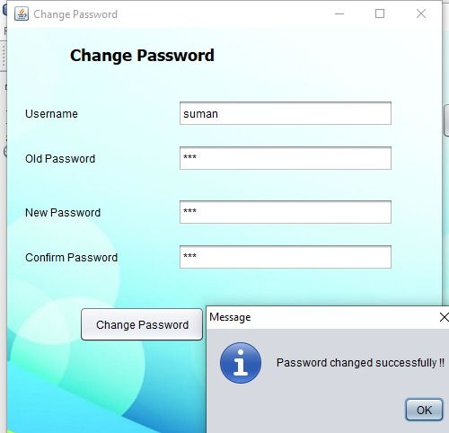

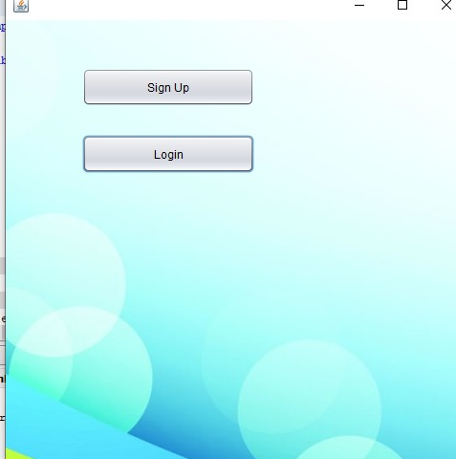

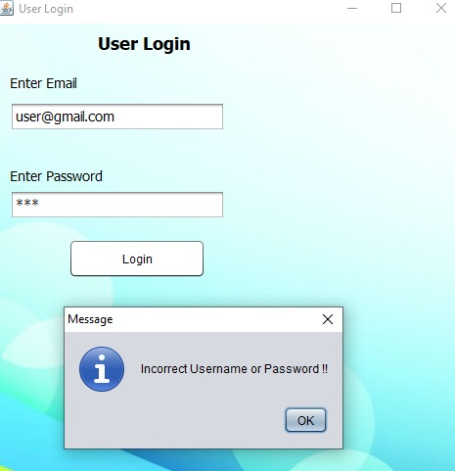

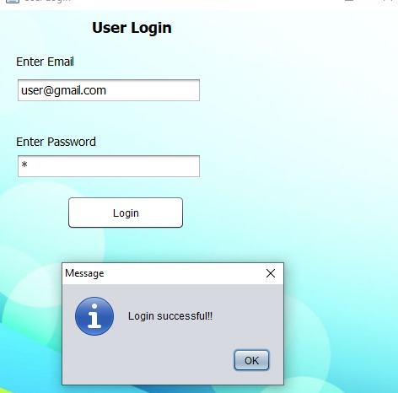

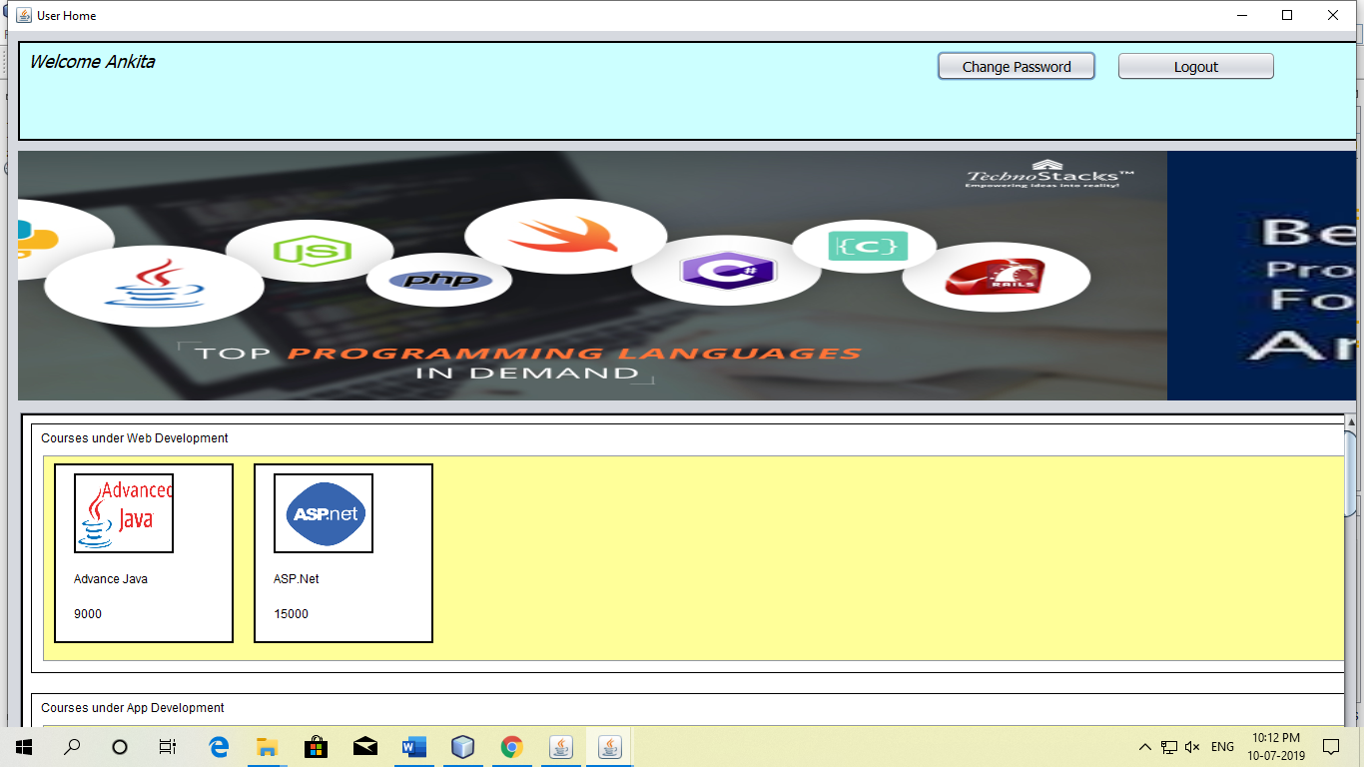

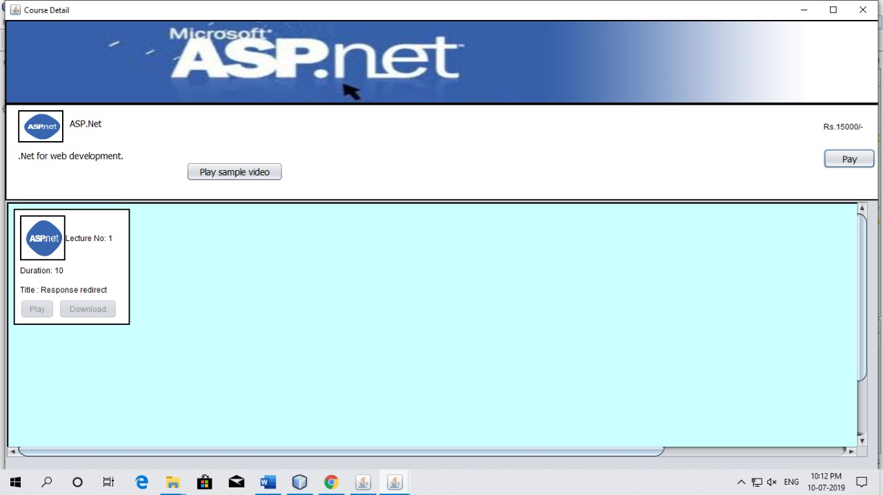

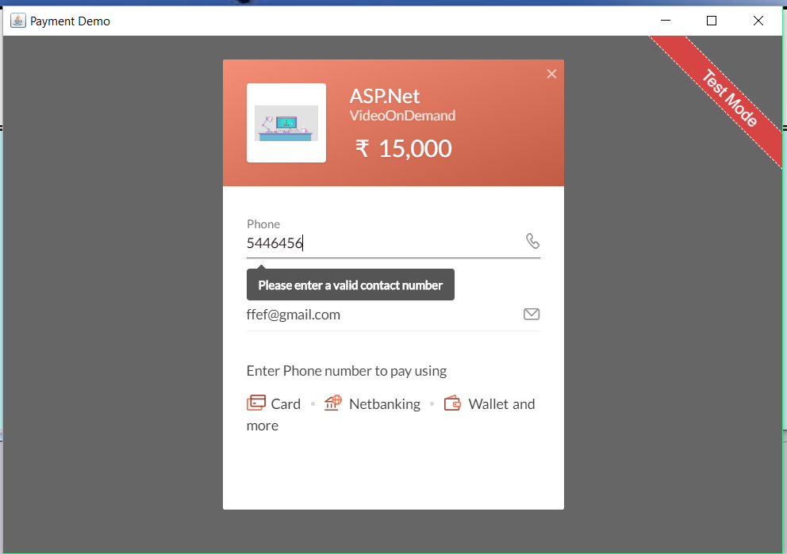

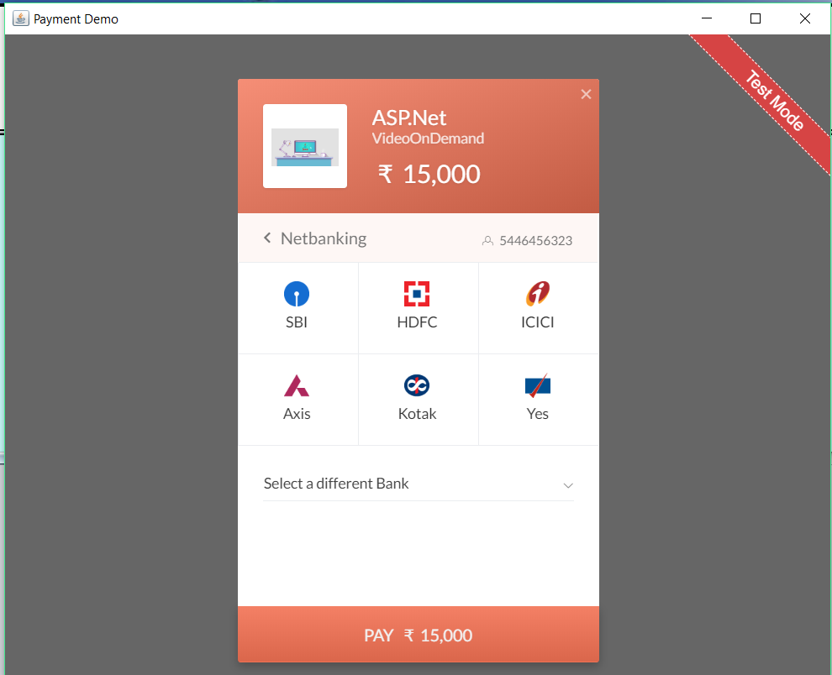

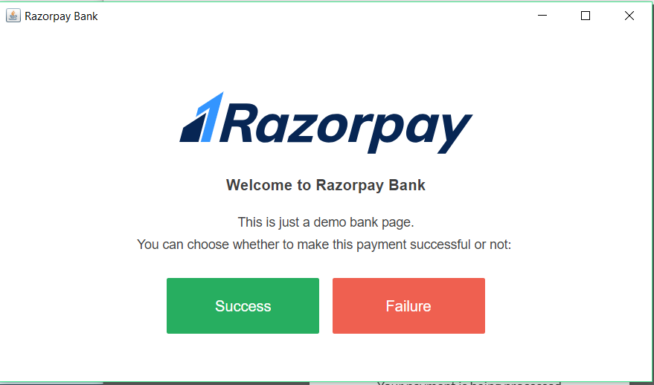

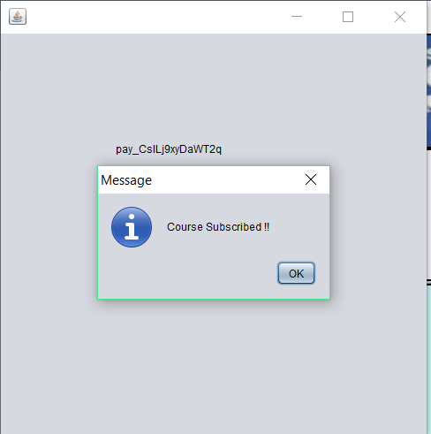

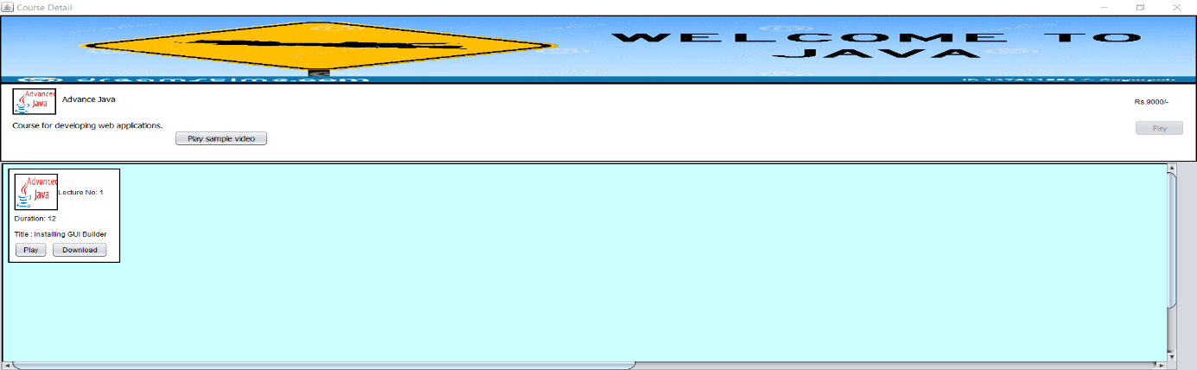

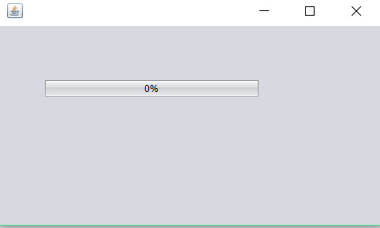

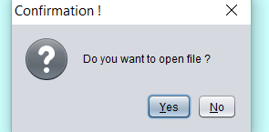

**BIBLIOGRAPHY**

* Java Study Notes by VMM Education
* Sun Certified Java Programming by Kathy Sierra
* [www.stackoverflow.com](http://www.stackoverflow.com/)
* [www.tutorialspoint.com](http://www.tutorialspoint.com/)